**Physical Retail in a Digital World**

Gabrielle Martinelli

LIM College

Abstract

Over the past decade, digital retailing has taken over. Due to internal and external factors, Americans are decreasing the time they spend in brick-and-mortar stores versus the time they spend on online retailers. This is due to the pandemic, a search for easier shopping, and a new lax lifestyle. This decrease in foot traffic in physical stores will immensely affect the way Americans see shopping, especially since online shopping is easier and more convenient. This case study will dive into how to keep brick and mortar stores alive with the addition of a subpar customer experience in store. To keep physical stores open, retailors will need to get creative and make the in-store experience fun with various events and incentives. In this case study, we will see how Marc Jacobs can be a force in the physical retailing world through customer experience.

Physical Retail in a Digital World

**Learning Objectives**

* Evaluate the fall of brick-and-mortar shopping and study the move to online shopping based on consumers lifestyles and psychographics that lead to a decrease in physical shopping.
* Identify new ways to keep a cadence instead of a decrease in brick-and-mortar using customer experiences, creativity, and incentives in Marc Jacobs flagship store.
* Launch and predict the success of a marketing plan for the chosen retailer by looking at other retailers’ successes with brick and mortar and by studying current market plans.

**II Introduction**

*Digital Retailing Vs Physical Retailing: The New Experience*

With the rise in digital shopping, retailors fear that they will lose the very thing that started them from the ground running: Physical shopping. This case study will dive into Marc Jacobs, and how their store experience could be catered to both Gen Z, and older generations in different product categories. With the newest brand from Marc Jacobs, called *Heaven* emerging, Gen Z fashionistas have found themselves shopping online for the latest drops. This new brand is extremely young and edgy, and the technological and physical concepts for this store are endless. Having an immersive experience in a flagship location in metropolitan cities across the United States will set the stage for Marc Jacobs to promote Heaven, as well as their contemporary brand and products.

This case study is extremely important as it lies within the culture of physical retailing. Keeping this culture alive, especially starting with big designers can make a lasting effect, saving physical retailing. The same way fashion trends trickle down from designers to wholesalers, the shopping trends will.

In the past decade, Marc Jacobs has been shifting perspectives and rebranding with the times which is extremely smart in comparison to brands like *BCBG by Max Mara* that have remained stagnant and have even gone bankrupt. With the resurgence of Marc Jacobs ready to wear styles, they have an opportunity to be extremely successful in the physical world, while also selling out in minutes on their digital site.

**III Business Problem(s)**

Marc Jacobs does not have a very interesting flagship. It has a prime location on Madison Avenue in New York City, but it is very simple for a flagship. In comparison to Saks Fifth Avenue’s flagship and The Gucci store in soho, March Jacobs falls behind in their visual merchandising and customer experience. According to *the 34 Best Flagship Stores in NYC | The COMPLETE Guide*, “It’s (Saks Fifth Avenue) one of the original stores responsible for helping to make fifth avenue a must-visit shopping destination…With outdoor light experiences, and intricate displays adorning each floor of Saks, it’s no wonder why many consider it to be one of the must-visit store’s flagship stores in NYC.” Saks has experiences that anyone visiting will never forget, especially around the Holiday’s with their outdoor lightshow, which quite literally brings consumers in in waves.

The Gucci store exceeds customer experience and visual merchandising to an extreme. The article, *User Experience: Gucci Wooster in SoHo*, explains the process of the customer experience in the Gucci store, and this can help identify what needs to be solved in Marc Jacobs stores. The author says, “. follow the snakes-and-ladders floor deeper into the store and start to realize you can buy everything you see. There is chinaware, upholstered chairs, cabinets, embroidered throw pillows, wallpaper, room dividers in metallic brocade and fruit punch plush fabrics.” Followed by “I try on a few pieces from the Dapper Dan collection because it’s debuting here and won’t be available elsewhere for a couple months, so it feels like a small scoop. It’s amazing.” (Whittick). This excerpt from this article shows the true effects of a perfect customer experience which include luxury, exclusivity, opulence, and the list goes on.

I sought out to compare reviews like the article above to other consumer reviews on Marc Jacobs store to see what the difference was. In the reviews from Yelp about Marc Jacobs, since there wasn’t much media coverage on the store (another issue), we could see the lack of luxury that is shown at this store. The reviews were great but were mainly focused on the instillation of the “Charlie Brown Peanuts” collection back in 2020. After digging through these reviews, many also loved the customer service that Marc Jacobs associates had.

Figure 1: Via Yelp

**IV Solutions**

From the comparison of the flagship stores, it is easy to see that the same things that work for one store, will work for most. Since the *Peanuts* instillation was such a hit, we can infer that a new instillation catered to the new wave of Marc Jacobs Heaven brand and there new line of purses will be extremely successful. The concept will be catered towards Gen Z, and contemporary fashion. The store will have bright and colorful notes. Devon Lee Carson, a business owner and vlogger has designed multiple pieces with Marc Jacobs for the *Heaven* line, and she can bring in loads of digital and physical sales. Heaven takes a new approach to design and translates the designer’s pop-culture interests into ready-to-wear pieces. These pieces include baby tees, pullover sweatshirts, and short dresses with bold graphics and logo prints, nodding to the 90s.

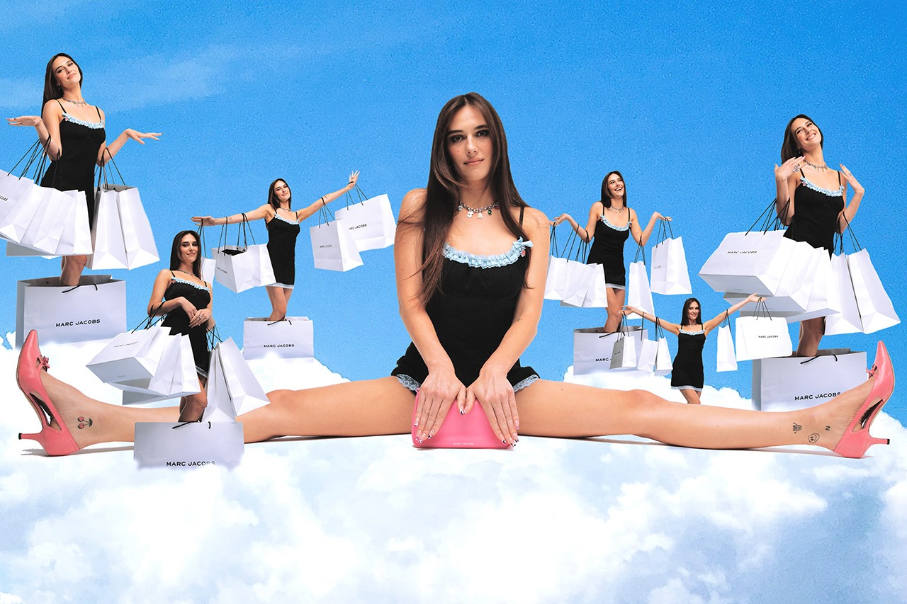Devon has designed multiple pieces with Marc Jacobs, and always posts about it on her vlog channels, even selling out on a new piece before she can even post about it publicly. With this new store concept including Heaven, Devon would be there at the grand opening. She would be taking pictures with fans, and the store would have a mini fashion show, showcasing all the new pieces, and the cult-favorites of the previous collections. With Devon included, a mix of digital and physical retailing will be like a melting pot. She has a huge fan base that flies across the country to meet her, meaning that this event would be huge, and would be broadcasted all over social media. Devon is also always featured in Vogue’s digital magazine, which will likely cover this event with us sending out a creative pitch to them and inviting an editor to the event.

Figure 2: MARC JACOBS HEAVEN COLLECTION

Following the Heaven collection, the newest collections of Marc Jacobs handbags will also have an instillation. Marc has a collection that has handbags with big writing on them. They are very trendy, and they read things like “The Tote Bag”, or “The Camera Bag”. These have gained huge popularity, especially in the contemporary/ urban space. Many are seen walking around New York in these bags, since they carry all the essentials, are budget friendly, and are durable. This new wave of purses will also get an instillation at the store.

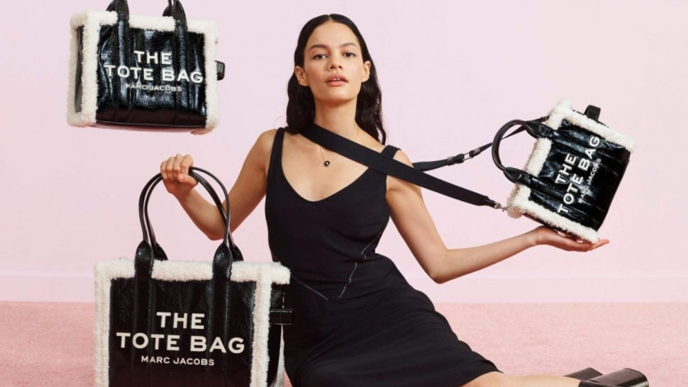

Figure 3: MARC JACOBS THE TOTE BAG EDITORIAL

Figure 4 1MARC JACOBS THE CAMERA BAG

This instillation will be more upscale and will have many elements. It will have a station where you can customize your tote from Monograms to purse essentials like wallets and card cases. This will bring more people into the physical store, as consumers tend to love the idea of personalization and individuality. For “The Camera Bag” we will have a photo booth station where anyone can come in to take printable photos with a Marc Jacobs logo that can also be digitally sent to the consumers phone, making it a mix between digital and physical elements.

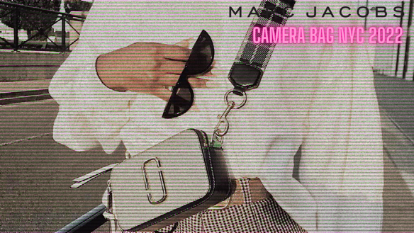**Photo Booth Concept:**

**V Conclusion**

With all these factors, Marc Jacobs has all the tools set up to have an amazing store front that will essentially save physical retailing. By working with influencers, we can combine digital and physical marketing and bring more people into stores. With a beautiful set of instillations that are interactive and fun, more people are inclined to visit, especially if it is in an urban city like New York city. The marketing plan that is set up will be effective and will again help join the life of digital and physical shopping. If this marketing plan is successful, we will open more similar stores in other urban cities and continue creating influencer collections and even collabs with other designers to keep that cadence going. This will allow the stores to continue to bring in consumers to the store, and to set an example for other designers and flagship stores.

**VI Two business questions to be answered by readers**

1. Do you think that physical retailing will stay relevant with the continuation and effort of consumer experience and art instillations?
2. Do you believe that influencers like Devon Lee Carlson will be the next wave of fashion by working with designers to keep physical retailing alive, and also to boost sales in the digital space?

References

2021, S. 27. D., Steffen, 2021, 27. D., & About the authorSteffenI'm a true New York fan! Not only have I visited the city over 20 times but also have I spent several months here at a time. On my blog I show you the best and most beautiful spots of the city. (2021, December 27). *▷ the 34 Best Flagship stores in NYC: The Complete Guide [Update 2022 ]*. Loving New York. Retrieved March 21, 2022, from https://loving-newyork.com/flagship-stores-in-nyc/

Google. (n.d.). Google search. Retrieved March 21, 2022, from https://www.google.com/search?q=marc%2Bjacobs%2B%22the%22%2Bbags&source=lnms&tbm=isch&sa=X&ved=2ahUKEwivsfPLwbr2AhWFVt8KHaq7ACQQ_AUoAnoECAIQBA&biw=1132&bih=695&dpr=2#imgrc=rH-4lqAjxn9ztM

Lam, T. (2021, August 3). *Devon Lee Carlson designs a very Y2K collection for Marc Jacobs*. HYPEBAE. Retrieved March 21, 2022, from https://hypebae.com/2021/8/devon-lee-carlson-marc-jacobs-collection-baby-tee-dress-hoodie-campaign-release

*Marc Jacobs - New York, NY*. Yelp. (n.d.). Retrieved March 21, 2022, from https://www.yelp.com/biz/marc-jacobs-new-york-21

*Marc Jacobs Prince St - New York, NY*. Yelp. (n.d.). Retrieved March 21, 2022, from https://www.yelp.com/biz/marc-jacobs-new-york-22

*Marc Jacobs*. fashion.com. (n.d.). Retrieved March 21, 2022, from https://www.julian-fashion.com/en-US/product/190183/marc_jacobs/crossbody_bags/the_camera_bag_crossbody_bag

Ssense. (2018, May 31). *User experience: Gucci Wooster in Soho*. ssense. Retrieved March 21, 2022, from https://www.ssense.com/en-us/editorial/fashion/user-experience-gucci-soho